**{{Patient_FamilyDoctor}}**

**⮽ fsdfsdf**

**□ fsdfsdfsd**

|  |  |
| --- | --- |
| **⮽ fsdfsdf** | **Yes □ No □** |
| **Fsadf □** | **rwer** |

**Yes □ No □**

**□Yes □ No**

**{{ServiceProvider_Signature}}**

**Arms, Legs and back pain {{Patient_Name}} {{Patient_BirthDate}}**

**{{ServiceProvider_FullName}}**

**{{ServiceProvider_Position}}**

**Initial Assessment**

**{{Patient_Signature}}**

|  |  |  |
| --- | --- | --- |
| **Presenting Symptom/Chief Complaint** | | |
| Patient c/c is pain at the entire back area with strong muscle spasm and movement limitation. | | |
| **Main Signs and Symptoms** | | |
| Pain is radiated to the arm and legs along the side and back of the legs involving the radiation of the pain to ankle and feet area.  {{Patient_Name}} | | |
| **Other Signs and Symptoms** | | |
| Patient is overwork, poor sleep, over reactive to all stress with a lot of muscle spasm at the back and legs area.  {{Patient_Name}} | | |
| **TCM Diagnosis and Treatment (identified TCM disease, TCM differentiation of syndromes)**  {{Patient_Name}} | | |
| Chronic obstruction, painful syndrome to the back with radiation along the arm and entire legs due to  {{Patient_Name}}cold and wind invasion. Qi stagnation with underlying Kidney Qi deficiency. | | |
| **Treatment Principles and Strategies** | | |
| Expel cold, remove wind. Blood and Qi circulation at the area. Nourish the Kidney Qi. | | |
| **Treatment Plan (Modalities; acupuncture, herbal, dietary, manual therapies), frequency and duration** | | |
| Acupuncture one time a week with 1 hour main tonification and immune enhancing protocol for 5-6 weeks, until the symptoms resolved. | | |
| **Any other Advice Given to Patients** | | |
| Acupuncture: Du14, Du3, Du4, Ren3, Ren4, K3, K6, K4. LI11, St36, Sp6 bilaterally with 45 min 1 hour tonification. Strong sedation with obtaining of needle sensation following by 45 min tonification for the main Yang channel to expel the wind and cold from the back area. GB20, GB21, UB11, UB10, UB56, UB58, UB60, UB62, GB30, UB36, St42, St43, St44. Stimulation of the Liv2 with Liv3 combination. | | |
| **Practitioner:** | **Date:** | **Signature:** |

**Dally Charting____________________________________Patient Name:**

**Date:**

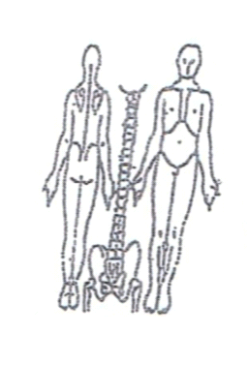 **Working Diagnosis:** Chronic obstruction syndrome of the back with radiation to leg and feet and arm due to cold and wind invasion Qi stagnation with underlying Ki Qi deficiency.

S: Patient is complaining of entire back pain with the radiation along the arm and leg.

O:

Treatment (P) Acupuncture: Du14, Du3, Du4, Ren3, Ren4, K3, K6, K4. LI11, St36, Sp6 bilaterally with 45 min 1 hour tonification. Strong sedation with obtaining of needle sensation, following by 45 min tonification for the main Yang channel to expel the wind and cold from the back area. GB20, GB21, UB11, UB10, UB56, UB58, UB60, UB62, GB30, UB36, St42, St43, St44. Stimulation of the Liv2 with Liv3 combination.

(A) Acupuncture 1 hour due to the protocol.

**Date:**

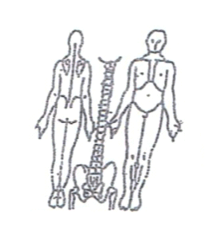**Working Diagnosis:**

S: Patient is still having pain at the entire back. Feeling much better after the procedure but pain and muscle spasm gradually coming back.

O:

Treatment (P)

(A) Acupuncture with Moxibustion for 1 hour with tonification.

**Date:**

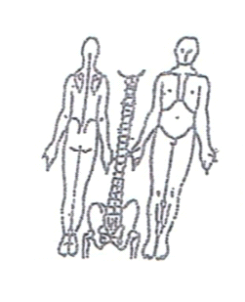**Working Diagnosis:**

S: Patient still having episode of pain and muscle spasm at the entire back area. Pain at the arm and legs much less. Sleeping better. Level of energy.

O:

Treatment (P) Acupuncture with Moxibustion 1 hour.

(A)

**Date:**

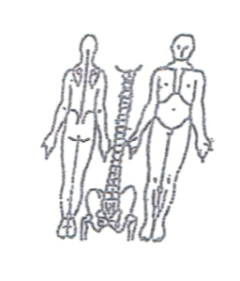**Working Diagnosis:**

S: Patient is sleeping N. ROM at the back area. Pain. No pain at the arm and leg area.

O:

Treatment (P) Acupuncture with Moxibustion 1 hour.

(A)

**Dally Charting____________________________________Patient Name:**

**Date:_**

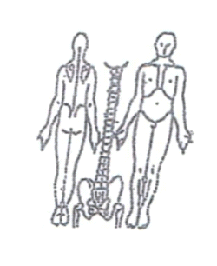

**Working Diagnosis:**

S: Patient feeling much better. Pain 1-2 times a week in much less intensity. N ROM, N appetite, N energy level.

O:

Treatment (P) Acupuncture + Moxa 1 hour according to protocol.

(A)

**Date:**

 **Working Diagnosis:**

S: Patient sleep N. No pain for entire week. N ROM. N level of energy. N daily living activity.

O:

Treatment (P) Acupuncture 1 hour with tonification. Start the remedial exercises for

10-15 min a day.

(A)